**LC Study Guide: OVerView of Acts 16-20**

**done in sync with**

**the “Living On Mission” sermon Series**

**Preface:** The purpose of this overview is to give our LC leaders a head-start on our sermon studies from Acts 16-20. Our objectives are to see a few reoccurring themes concerning the gospel, highlight a few insights in the text, and gain a basic familiarity with this section. For more, please see the accompanying video of the overview recorded on 9/15.

The LC Team will continue to provide studies every other week to match the LC calendar – the next one will be for 9/22. As always, we would be happy to connect with you on any questions or clarifications you might need. Grateful you and your LC are engaging the Scriptures in this way.

**Acts 16:1-10 – Timothy and Paul’s Vision of the Man of Macedonia**

**Theme to Note:** The gospel is needed by those unaware of their specific need

The Macedonian Call (16:1-10)

**Textual Insight:** The Macedonian man does not speak for all the Macedonians. We would assume that a large percentage of the population were not interested in this new ideology centered on Jesus. The vision of the man is about their need, not their want.

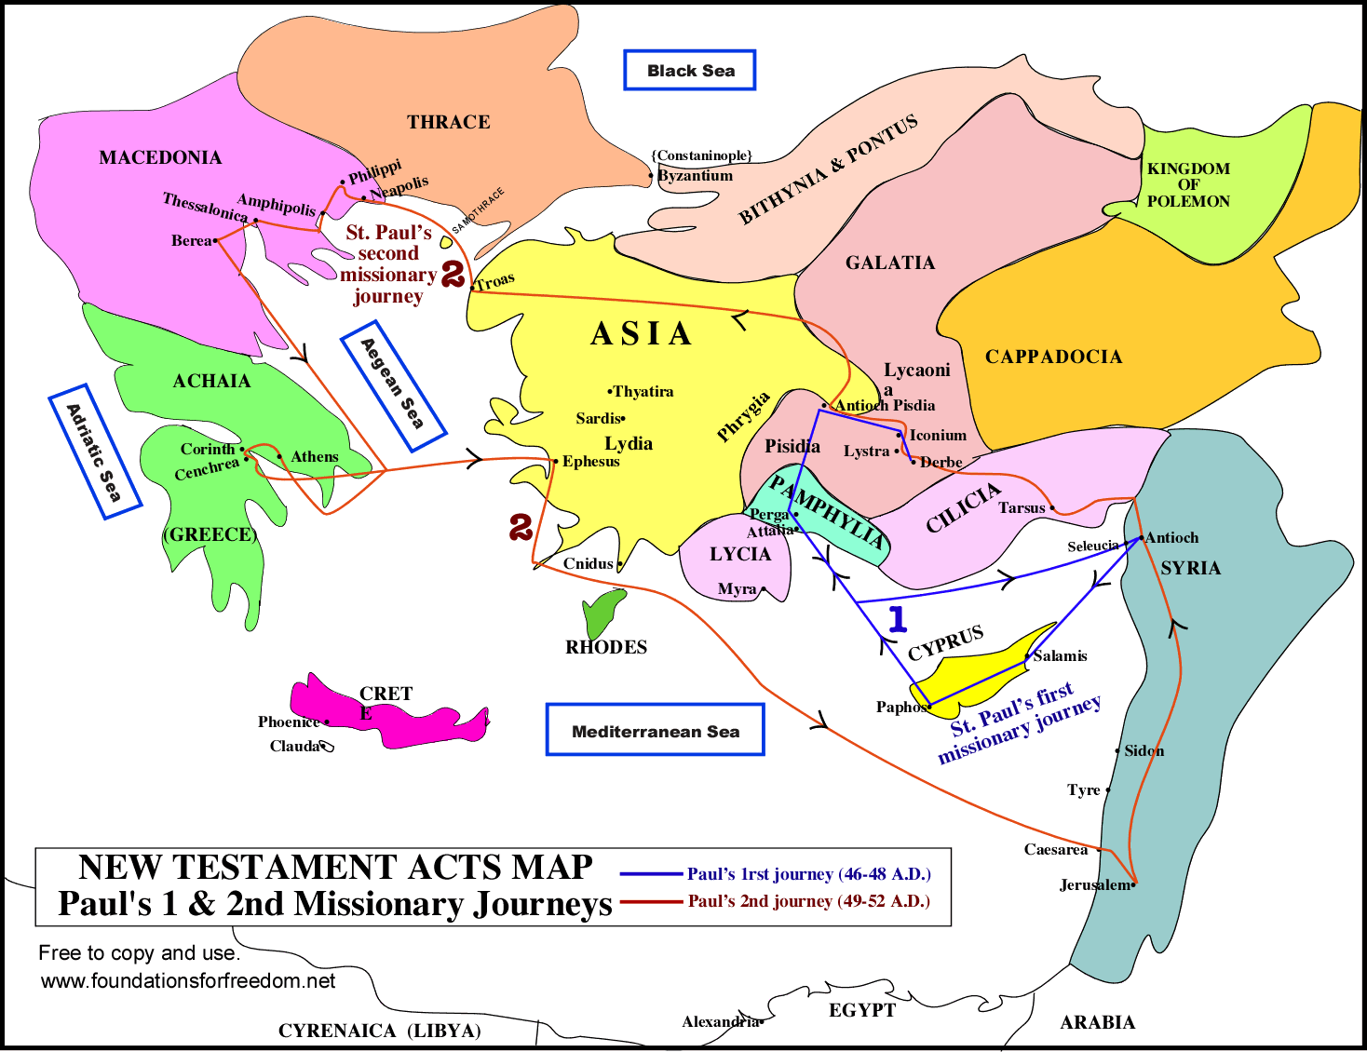

**16:11-15 – Lydia’s Household Converted in Philippi**

**Theme to Note:** God is already at work

**Textual Insight:** Paul begins his new mission in Philippi by going out by the river to pray (as there was no synagogue in Philippi). He enters into conversation with a wealthy merchant woman and the text says, “The Lord opened her heart to respond to Paul’s message.” This is not a chance encounter; she’s there to pray and likely has been seeking God’s will.

**16:16-24 – Paul Heals an Enslaved Girl**

**Theme to Note:** The offensive and powerful nature of the gospel. (More specifically: The gospel disrupts social power.)

**Textual Insight:** These men have enslaved this young girl who had powers of divination to predict the future. When Paul heals her from the demonic hold, not only is the girl spiritually freed but there are now negative financial implications for those profiting from her slavery and oppression. Angry, they go after Paul and Silas.

**16:25-34 – Jailer’s House is Converted & Paul and Silas Released**

**Theme to Note:** God does not abandon his servants who preach the gospel but empowers them.

**Textual Insight:** Paul and Silas are not singing out of their boredom but out of their pain. This is the first time that Paul is on the receiving end of the beating from the Christian message. Physically assaulted, publicly humiliated, emotionally violated, their prayer and worship is a time of calling out to God for re-centering and healing.

After leading the jailer and his household to Christ, word is sent that Paul and Silas are to be freed. But instead of slipping out immediately, they demand to be escorted out by the magistrates. In doing so, it is a dramatic public apology and it acknowledges their Roman citizenship.

**17:1-15 – Paul in Thessalonica and Berea**

**Theme to Note:** The offensive and powerful nature of the gospel. (More specifically: The gospel disrupts social power.)

**Textual Insight:** Paul goes to the synagogue, discusses the validity of Jesus with the Scriptures, and some are persuaded. This sounds the alarm to the Jewish establishment.

**17:16-34 – Ministry in Athens, the Areopagus Speech**

**Theme to Note:** The offensive and powerful nature of the gospel. (More specifically: The gospel can sound offensive and ridiculous to the non-Christian.)

**Textual Insight:** Offended by the idols of Athens, Paul responds by comparing the respective narratives of the Epicurean and Stoic philosophers. They take him to the Areopagus (think of this scene as intellectual senate hearing) and Paul proclaims Christianity. Typically we think Paul is using the altar to the “Unknown God” as an entry point but he’s doing more than that. In fact, he’s challenging their entire religious system in verse 25. Paul tells them God does not need their idols, sacrifices or anything from them – God is the great provider! What God desires is our repentance (vs. 30-31). Some believed (like Dionysius), some rejected, some wanted to hear more.

**18:1-22 – Paul in Corinth**

**Themes to Note:** The gospel taking root in hearts and communities. God does not abandon his servants who preach the gospel but empowers them.

**Textual Insight:** The gospel is spreading and taking shape in Corinth. Per the Lord’s instruction, Paul stays here for a year and six months. Though some of the Jews opposed him, Crispus, one of the synagogue leaders, becomes one of the building blocks of the new Christian community in Corinth. Soon, Paul will focus his ministry on the Gentiles in Corinth.

Still the Jews seek to rid Corinth of Paul and bring him before Gallio who vindicates the apostle and ejects the Jews from his court. The ruling gives Paul and the blossoming Christian community inner stability and public credibility, which allows Paul to continue on his missionary journey to Ephesus and Antioch.

**18:23-28 – Paul’s Third Journey Begins and the Completion of Apollos**

**Theme to Note:** The gospel at work in other individuals and communities.

**Textual Insight:** As Paul returns to Galatia and Phrygia (where he wandered before the “Macedonian Call”), Priscilla and Aquilla meet Apollos, a highly educated, well-articulated Jewish man who has been living and studying in Alexandria, one of the oldest and strongest Christian communities in the early centuries. Alexandria was the home of some of early Christianity’s greatest scholars (Clement and Origen), the famous philosopher, Philo and also contained a large Jewish population.

It’s in Ephesus that Priscilla and Aquilla help fill some of Apollos’ Christian theology and it will be in Corinth that Apollos’ teaching helps the Corinthian church Paul founded.

**19:1-22 – Paul in Ephesus**

**Theme to Note:** Obedience is the only response to God’s plan.

**Textual Insight:** Paul finally gets to Ephesus after being told by God to wait (16:8, 18:21) and this a key city for the providence of Asia.

By going the “interior route” of Phrygia, Paul is able to visit Lystra, Iconium, Pisidian Antioch. Upon arriving in Ephesus, he meets some disciples who are in need of the teaching of the Holy Spirit, baptism, and Pentecost. The Holy Spirit fills them and the mission in Ephesus takes root.

Here again, Paul will debate with the Jewish leaders, some believe, many oppose and eventually Paul will focus his energy on teaching the twelve Ephesian disciples and publicly lecture in the hall of Tyrannus for two years.

It’s here Paul is at his most influential point of his ministry. Many Jews know his reputation, Christians regard him as an apostle of God, his letters have been widely circulated (and he’s still writing), he experiences disputes, resolutions, and continues proclaiming the gospel to Jews and Gentiles now in one of the most powerful and influential cities in the ancient world.

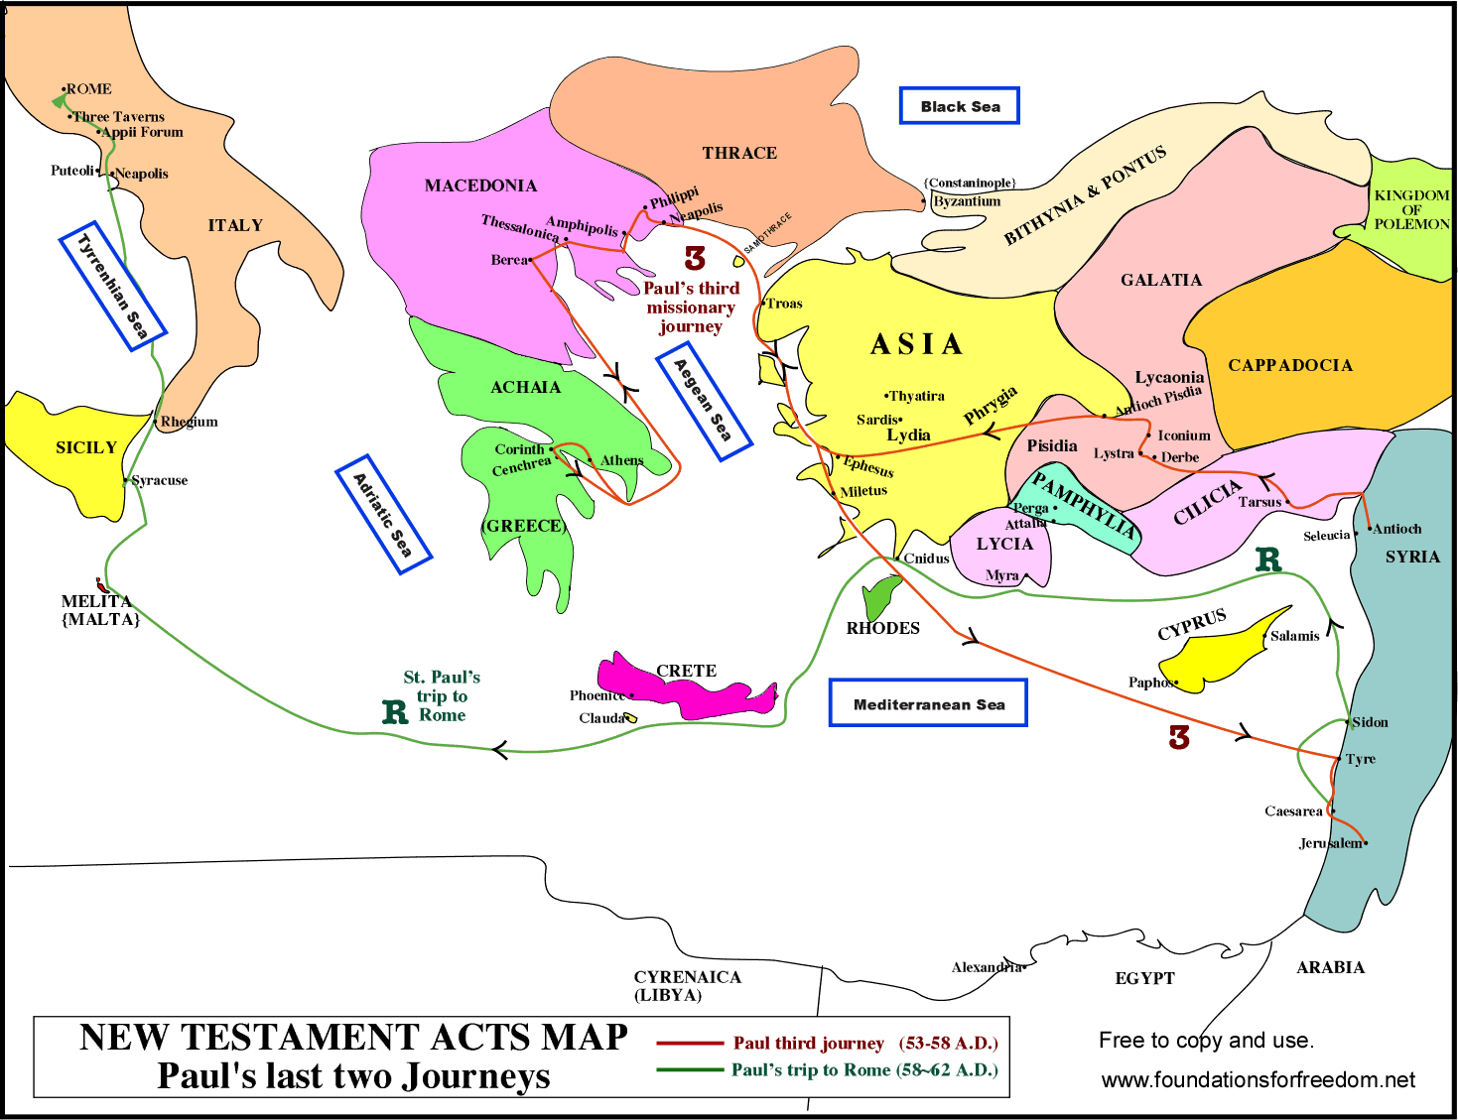

**19:23-41 – The Evangelization, Miracles and Riots of Asia**

**Theme to Note:** The offensive and powerful nature of the gospel.

**Textual Insight:** Once again we see God doing mighty things through Paul and once again we see how the establishment reacts to changed lives and the control of power. Eventually a huge riot forces Paul to move on from Ephesus and headed to Macedonia.

**20:1-38 – Paul’s farewell to the Ephesian elders and heading to Jerusalem**

**Theme to Note:** Obedience is the only response to God’s plan.

**Textual Insight:** Clearly it is difficult for Paul to leave Ephesus. From the text we see that he truly desires to stay. He is so close to the Ephesian elders that even after he leaves Ephesus, he arranges for them to meet him in Miletus.

It’s here he tells them in v. 24, “...if only I may finish the race and complete the task the Lord has given me – the task of testifying to the gospel of God’s grace.” He charges them with continuing the mission, they prays, and Paul and his companions set sail to Jerusalem.

**Recommended Resources:**

*Acts for Everyone Part 2* by Tom Wright (Westminster John Knox Press)

*The Message of Acts* by John Stott (Inter Varsity Press)