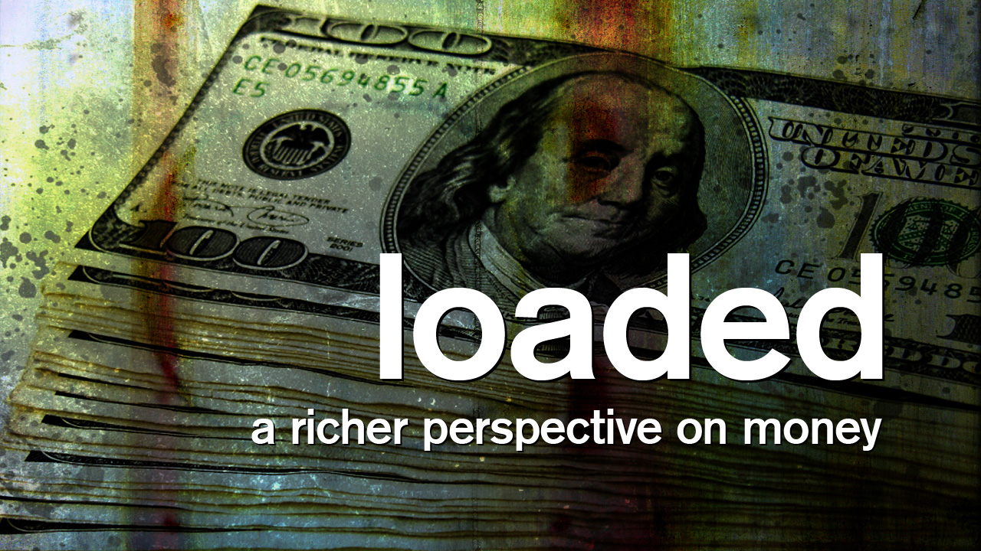
Oasis: How to Be generous
Done in sync with
our “LOADED” series
The Passage – Mark 12:41-44

Preface: Welcome to our LC Bible study in our January sermon series “Loaded.” These LC studies will complement the sermons, often using the same biblical texts, and will help your LC go deeper in personal understanding and application. The italicized portions are meant to resource and help you in leading – not to be distributed to the entire group (it limits conversation).
For this week’s study, our hope is that you will spend the first half of your time discussing this short but “loaded” Scripture passage (Part 1), and then the second half or your time discussing the accompanying handout on the five stages of giving (Part 2). Indeed, each of us can be great givers!

Study’s BIG Idea: We can all be great givers, regardless of our financial situation.

Life Community--opening question and transition:

Try to think of someone who either modeled or taught you about the importance of giving or generosity. Anyone want to briefly mention who you thought of and what came to mind?
(Hopefully, 3-4 people will share about a person who influenced them. Spend 3-5 minutes on this.)

Today, we will have two parts to our discussion. First, we will plunge into a somewhat famous but brief biblical passage, sometimes referred to as the “Widow’s mite.” Then, second, we will review together the chart the Pastor Bryan mentioned in his recent sermon—about the five stages of giving. Regardless of your financial situation or realities, each of us can be great givers in the sight of God.

So, let’s plunge into Part 1--the passage!

Mark 12: 41-44 (NIV © 2011)
Read aloud (also, some people like a couple of minutes for individual study and reflection, which increases their likelihood to contribute to the discussion).

⁴¹ Jesus sat down opposite the place where the offerings were put and watched the crowd putting their money into the temple treasury. Many rich people threw in large amounts. ⁴² But a poor widow came and put in two very small copper coins, worth only a few cents.
⁴³ Calling his disciples to him, Jesus said, “Truly I tell you, this poor widow has put more into the treasury than all the others. ⁴⁴ They all gave out of their wealth; but she, out of her poverty, put in everything—all she had to live on.”

Vv. 41-42 – the situation

O – What do you observe about the context? What is Jesus doing?

O – In v. 42, what are some of the contrasts that you notice?
(n.b. References to currency in the Scriptures refer mostly to Roman or Greek money. The coin mentioned in this passage, a lepton, (and the parallel passage in Luke 21) is the only reference to a Jewish coin. It was basically the smallest imaginable coin, and a 1962 reference book was estimated its value as 1/8 of an American cent then!)

I – Given the many rich contributors, what might have been some of the different motivational factors
that motivated their giving?

I – What might have motivated the poor widow?

I - Do you think many other people saw what the widow did? Why or why not?

Vv. 43-44 – Jesus explains

O – What does Jesus clarify about what has occurred?

I – In what possible way/s has the widow “put more into the treasury than all the others”?

(Daring question: Any chance that Jesus was wrong about this?)

I – What would be the equivalent for us if we contributed all that we “had to live on”?

I – What do you think Jesus wanted to impress upon his disciples?

A – What should our “take-away” insight be? Put it in your own words.

A – What are some ways we can practice this kind of sacrificial giving?

Part 2 – The 5 stages of growing in our generosity

- Read out loud the 5 different stages starting at the bottom, stopping to clarify or discuss each one as you do.

The Sacrificial Phase
Giving to the point of loss; beyond reasonable expectation
Dangers: recklessness; irresponsibility
Growth: discernment; contentment

The Abounding Phase
Beyond tithing; constant, strategic investment in Kingdom-causes
Dangers: pride; control
Growth: humility; influence

The Maturing Phase
Seeing self as a steward; increasing giving incrementally toward tithing
Dangers: legalism; judgementalism
Growth: discipline; cheerfulness

The New Phase
Beginning to give; spontaneous, impulsive
Dangers: getting stuck; thoughtlessness
Growth: consistency; intentionality

The Needy Phase
Limited capacity to give due to financial hardship and/or spiritual struggle
Dangers: despair; covetousness
Growth: faith; contentment

- Ask the group to try to figure out where they are. Where do you see yourself?

(n.b. Please don’t force anyone to talk. Let people volunteer and speak up on their own, if they are willing. This is meant to help and motivate people, not put them on the spot or embarrass them or be invasive.)

- Ask: How can we help one another grow in our financial stewardship? What might help you? How can we encourage one another?

Prayer: For our continued growth in generosity—and even for the spirit of sacrificial giving.

Key: O – Observation. I - Interpretation. A – Application

- Please note that not all these questions are to be asked in a single night. Take some time and select and reword the questions that best fit your voice and your LIFE Community group. Certain questions work better for certain groups. You are encouraged to prayerfully discern what will serve your LC the best.
- Complement OIA questions with “process questions” (what else? what more? what do others think?).
- When you ask questions, give people ample time to think and respond. Wait. Take your time; don’t rush people but encourage their participation. And avoid answering your own questions!
- Timing/pacing: allocate your time and move forward gently, with a steady pace.
- Application: Pace the study to conclude with “difference making” application.
- Secondary texts—use other texts sparingly, even if they are relevant. Such texts will push you into “teaching,” rather than facilitating. It can cause people to feel distracted or de-powered.

