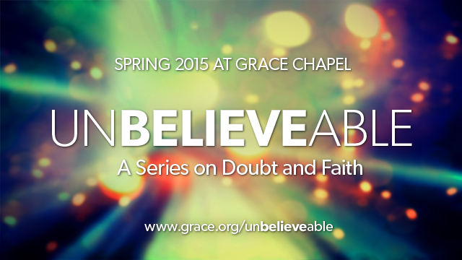
LC Study Guide

Done in Sync with the "unBELIEVEable" Series
The Passage: Revelation 21:1-5a
For Life Community usage the week of 4/26/15

Welcome and prayer.

Intro: When thinking about the Christian faith we often note how reasonable and historical it is, but we should also consider how beautiful it is. Today, let's look at the connection between beauty and faith and how God is at work.

- What are some of the beautiful moments you have experienced in your life?
- What are some of the beautiful moments you experienced this past week?

As we consider beauty, we must also consider what is ugly, what is broken, what is not beautiful. What are some examples of that?

Read Revelation 21:1-5a (NIV)

¹ Then I saw "a new heaven and a new earth," for the first heaven and the first earth had passed away, and there was no longer any sea. ² I saw the Holy City, the new Jerusalem, coming down out of heaven from God, prepared as a bride beautifully dressed for her husband. ³ And I heard a loud voice from the throne saying, "Look! God's dwelling place is now among the people, and he will dwell with them. They will be his people, and God himself will be with them and be their God. ⁴ 'He will wipe every tear from their eyes. There will be no more death' or mourning or crying or pain, for the old order of things has passed away."

⁵ He who was seated on the throne said, "I am making everything new!"

What do you see and imagine in this new heaven and new earth? Consider how it is described in terms of look and feel. What excites you the most? What do you find confusing or intriguing?

While this is not a study on "final things" or the book of Revelation, it's interesting to note in John's vision (v. 1) that "there was no longer any sea." While there is speculation on exactly what this means, N.T. Wright suggests that to Israelites especially, the sea represented danger from where "the beast had arisen to threaten humanity" (13:1, 12:12), and something to be delivered from/through (think of the Exodus story). What threatens us? Where does our danger come from? What do we need to be delivered from? What are the "seas" of today?

Consider the relational language. In the "new heaven and new earth," what do our relationships look like?
What does it mean to you that God is making all things new and beautiful?
How does beauty interact with our doubts? How does God's commitment in making all things new and beautiful strengthen our faith?
How does this inform how we apply this hope and live our lives today?

Close in prayer.

- Please note that not all these questions are to be asked in a single meeting. Take some time and select and reword the questions that best fit your voice and your Life Community group.
- Certain questions work better for certain groups. You are encouraged to prayerfully discern what will serve your LC the best.
- Complement these questions with "process questions" (what else? what more? what do others think?).
- When you ask questions, give people ample time to think and respond. Wait. Take your time; don't rush people but encourage their participation. And avoid answering your own questions!
- Timing/pacing: allocate your time and move forward gently, with a steady pace.
- Application: Pace the study to conclude with "difference making" application.
- Secondary texts—use other texts sparingly, even if they are relevant. Such texts will push you into "teaching," rather than facilitating. It can cause people to feel distracted or de-powered.

