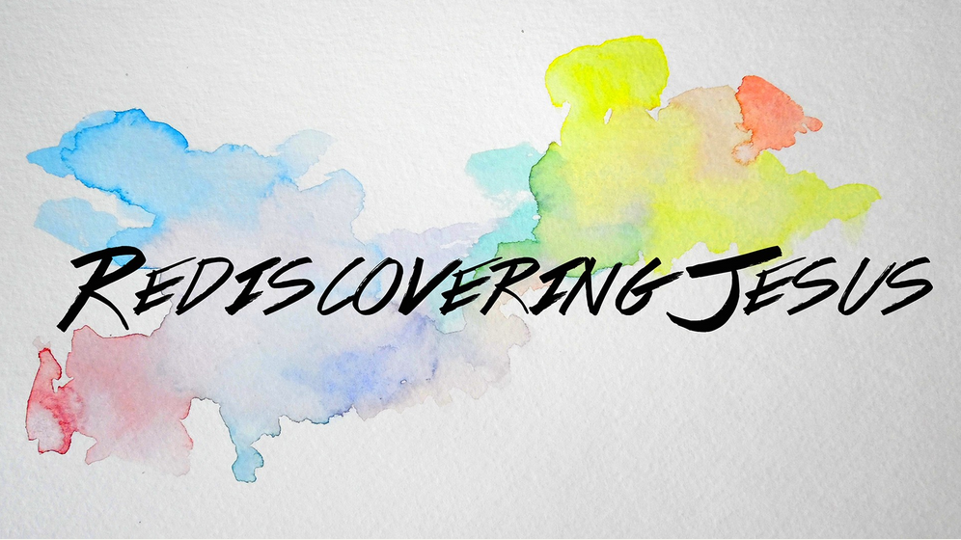
LC Study Guide

Done in Sync with the Rediscovering Jesus Series
The Passage: Matthew 1:18-25
For Life Community usage the week of 11/30 - 12/13/15

Intro: Each year it feels like Advent sneaks up on many of us. After a busy fall, then the rush of Thanksgiving, we often find ourselves launched into an even faster rush as we race towards Christmas. But Advent is intended to be a time of spiritual preparation and we begin by looking at the story of the virgin birth of Jesus.

Intro Questions:
- If you were creating a fictional story of a deity type entering our world, how would it begin?
- Describe how you have related to the story of Jesus' birth over the years.

Central Point – Jesus enters our world paradoxically, in both the most natural and super-natural of ways.

Matthew 1:18-25

18 This is how the birth of Jesus the Messiah came about: His mother Mary was pledged to be married to Joseph, but before they came together, she was found to be pregnant through the Holy Spirit. 19 Because Joseph her husband was faithful to the law, and yet did not want to expose her to public disgrace, he had in mind to divorce her quietly.

20 But after he had considered this, an angel of the Lord appeared to him in a dream and said, "Joseph son of David, do not be afraid to take Mary home as your wife, because what is conceived in her is from the Holy Spirit. 21 She will give birth to a son, and you are to give him the name Jesus, because he will save his people from their sins."

22 All this took place to fulfill what the Lord had said through the prophet: 23 "The virgin will conceive and give birth to a son, and they will call him Immanuel" (which means "God with us").

24 When Joseph woke up, he did what the angel of the Lord had commanded him and took Mary home as his wife. 25 But he did not consummate their marriage until she gave birth to a son. And he gave him the name Jesus.

O – Imagine being a friend of Joseph listening to him debrief his encounter with the angel and contemplating his dilemma regarding his pregnant fiancée. This likely would not have been the first time you've heard of an unplanned pregnancy. The angel story, however, would likely leave you without any reference points. Now you know a little of what Joseph is feeling. What would you find striking in his story and what thoughts would you have for him?

I – Though it's nearly impossible for us to understand, a single pregnant woman in Mary's society risked being stoned or exiled. In a world where God gives free will, why would He put Mary in such a position that risked her life and the birth of Jesus as well? Why not have Jesus beam down like in Star Trek or take a space ship like Super Man? Why enter this world as an ordinary baby?

I – The angel quotes Isaiah 7:14 (vv 21-23). It's long been debated if the Hebrew word "almah" is to be interpreted as a "young woman" or "virgin." How does the passage change from one interpretation to another? In your mind, does Jesus lose any measure of divinity if He is born to an "ordinary young woman" or born in an "extraordinary" way to a virgin? If Jesus does not lose any measure of divinity, what is the purpose of the story?
(In short, Matthew writes this story for at least two reasons. One is to simply report what happened. Secondly, he shows the reader this paradox of the ordinary and the extraordinary way of Jesus.)

A – As we prepare our hearts this Advent, we are reminded that with God, all things are possible. As we reflect on the story of the virgin birth of Jesus, what do you find encouraging, disconcerting, or inspiring as we journey on to Christmas in our everyday lives?

- Please note that not all these questions are to be asked in a single meeting. Take some time to prayerfully discern what will serve your LC the best. Select and reword the questions that best fit your voice and your Life Community group.
- Complement these questions with "process questions" (what else? what more? what do others think?)
- When you ask questions, give people ample time to think and respond. Wait. Take your time; don't rush people but encourage their participation. And avoid answering your own questions!
- Application: Pace the study to conclude with difference-making application.
- Secondary texts—use other texts sparingly, even if they are relevant. Such texts will push you into "teaching" rather than facilitating. It can cause people to feel distracted or de-powered.

