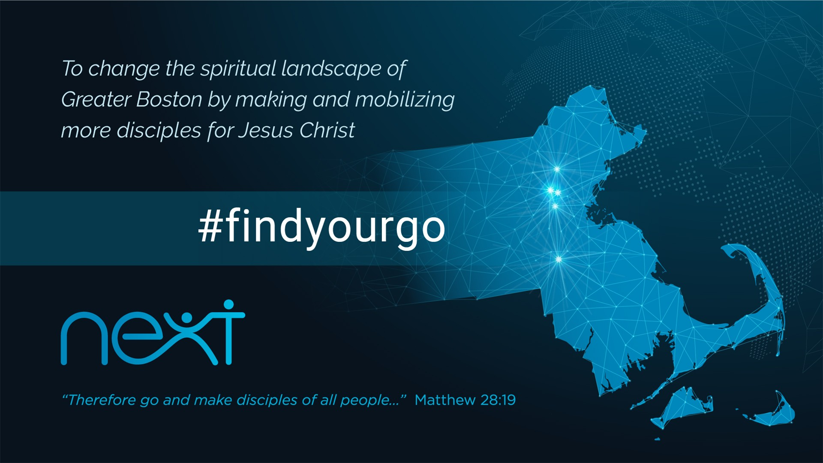
LC Study Guide

“Find Your Go!” Series
The Passage: Matthew 28:16-20
January 9 – January 22

Intro:
We kick off the new year with some big-picture vision-casting in our Next: Find Your Go! Series. May we grow in our understanding of the Kingdom of Jesus and our context as a Christian faith community in Greater Boston. The New Testament describes that we all have a role to play, we all have a calling, we are all part of the mission. A key passage in understanding this takes place after Jesus’ resurrection and shortly before His ascension. Today we want to look at “The Great Commission” and see what that means for us individually and as a faith community.

Matthew 28:16-20

¹⁶ Then the eleven disciples went to Galilee, to the mountain where Jesus had told them to go. ¹⁷ When they saw him, they worshiped him; but some doubted. ¹⁸ Then Jesus came to them and said, “All authority in heaven and on earth has been given to me. ¹⁹ Therefore go and make disciples of all nations, baptizing them in the name of the Father and of the Son and of the Holy Spirit, ²⁰ and teaching them to obey everything I have commanded you. And surely I am with you always, to the very end of the age.”

O – Some of us have who have been around the church for a while have read this text and heard countless sermons on “The Great Commission.” Yet we know that sometimes the Scriptures speak anew to us. So with fresh eyes, let’s re-read these words aloud and then privately to ourselves. What sounds new and fresh to you? What resonates loudest and truest to you today?

I – What do you make of what Matthew tells us in verse 17, that upon seeing again the risen Jesus, “they worshipped him but some doubted?”

(We can speculate on a few things here. First, the most obvious is that there is often a great struggle between faith and doubt that even the most faithful have wrestled with. Second, some theologians speculate that despite their love for Jesus, they were Jewish monotheists, meaning they only worshipped YHWH and did not know exactly what to do with Jesus. Matthew may be recording this detail for his predominantly Jewish audience in order to bring normalcy to his readers. Yes, even some of the disciples struggled, but even they believed and this gospel is about proclaiming that Jesus is the Son of God. Also brilliant are the last words of Matthew’s Gospel. “I will be with you always…” echo the words in Matthew 1:23, Jesus being Emmanuel, “God with us.”)

O – Observant readers of Matthew will read v. 18 and remember that Jesus was tempted by the devil with his enticements of authority and power without having to suffer. Here Jesus stands risen, triumphant, and with all authority from the Father commissioning His followers. Identify the four commands Jesus gives His disciples.
(Go, disciple, baptize, teach.)

I – The first command “Go” is in participle form (as opposed to verbal imperative). Meaning it’s not “Go somewhere” but better understood as “As you’re going through life…” How might this this change your understanding of this commissioning?
(To paraphrase, Jesus is saying, “As you go along in life, disciple others, baptize them, teach them to obey the commands I have taught you.” This universalizes the command to all Christians and makes it an everyday practice of bringing Jesus’ reality of heaven here on earth.)

A – It’s understandable that The Great Commission may be intimidating on some level. No one wants to get Jesus’ final earthly words wrong. But His insistence that He is always with us ought to bring us comfort and courage as we go about proclaiming His good message. What everyday things do we already do and what can we grow in as we live out Jesus’ Great Commission to all His followers?

- Please note that not all these questions are to be asked in a single meeting. Take some time to prayerfully discern what will serve your LC the best. Select and reword the questions that best fit your voice and your Life Community group.
- Complement these questions with “process questions” (what else? what more? what do others think?)
- When you ask questions, give people ample time to think and respond. Wait. Take your time; don’t rush people but encourage participation. Avoid answering your own questions!
- Application: Pace the study to conclude with difference-making application.
- Secondary texts—use other texts sparingly, even if they are relevant. Such texts will push you into “teaching” rather than facilitating, causing people to feel distracted or de-powered.

