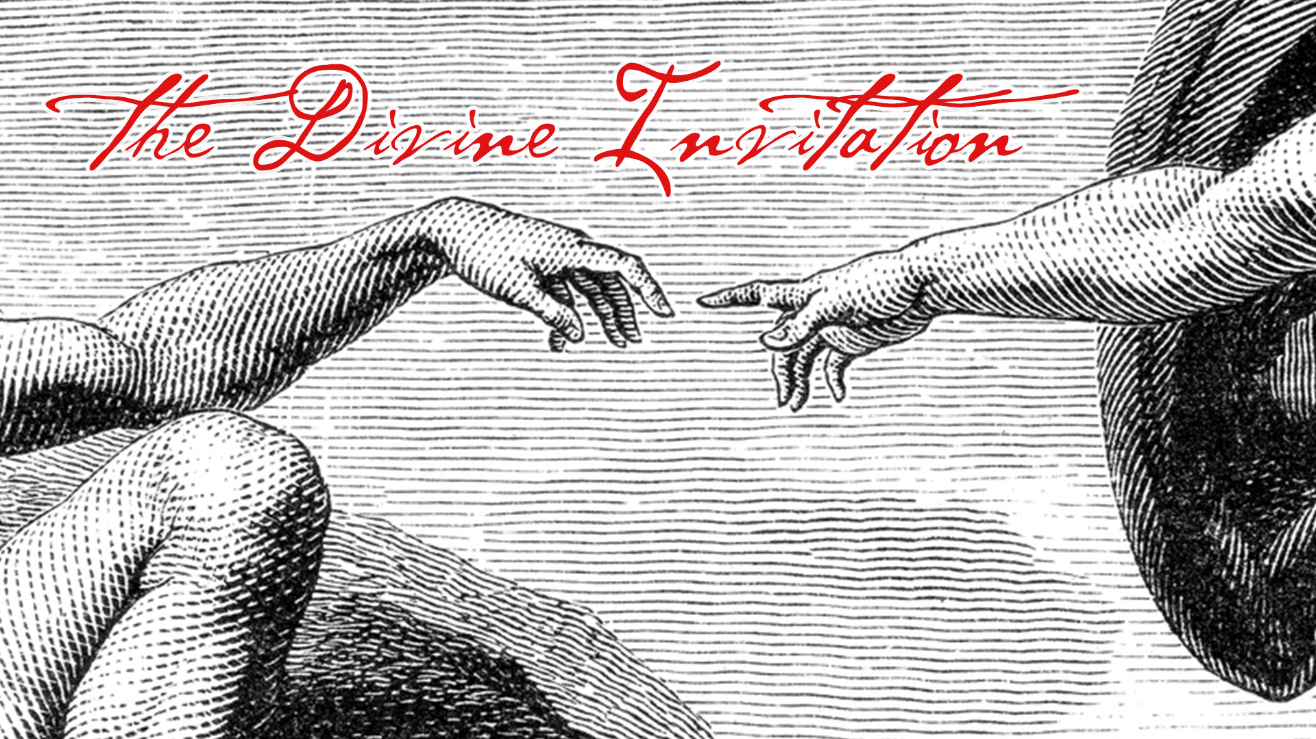
LC Study Guide
The Divine Invitation
The Passage: Matthew 5:13-20
September 18 – October 1

Introduction:
Welcome to a new ministry year and our new series, “The Divine Invitation.” Today, we want to take a closer look at a portion of Jesus’ Sermon on the Mount, one of the most familiar texts of Scripture. Aided by the Holy Spirit, and served by the virtues of community, we hope to uncover something new and fresh that we can apply to our lives.

Transition to our text:
Take a few moments to read the passage twice. Give yourself the communal blessing of “meditating” (which literally means to “chew on”) on the familiar words of Jesus.

Matthew 5:13-20
¹³ “You are the salt of the earth; but if salt has lost its taste, how can its saltiness be restored? It is no longer good for anything, but is thrown out and trampled under foot.
¹⁴ “You are the light of the world. A city built on a hill cannot be hid. ¹⁵ No one after lighting a lamp puts it under the bushel basket, but on the lampstand, and it gives light to all in the house. ¹⁶ In the same way, let your light shine before others, so that they may see your good works and give glory to your Father in heaven.
¹⁷ “Do not think that I have come to abolish the law or the prophets; I have come not to abolish but to fulfill. ¹⁸ For truly I tell you, until heaven and earth pass away, not one letter, not one stroke of a letter, will pass from the law until all is accomplished. ¹⁹ Therefore, whoever breaks one of the least of these commandments, and teaches others to do the same, will be called least in the kingdom of heaven; but whoever does them and teaches them will be called great in the kingdom of heaven. ²⁰ For I tell you, unless your righteousness exceeds that of the scribes and Pharisees, you will never enter the kingdom of heaven.

O – What words and phrases resonated with you as the passage was read?

O – For the sake of conversation, which metaphor do you relate to most: Jesus identifying you as the “salt of the earth,” the “city on the hill,” or a “light on a lampstand”? Why?

I – Why do you think of all metaphors, Jesus used “salt,” “light,” and a “city on a hill” as the means to make his point?
(In the ancient world, salt was used to preserve food and of course, to add flavor. Also, in the ancient world, light was used to see things - The times have changed
Throughout the Sermon on the Mount, the problem Jesus was calling out is that Israel had not lived up to its calling to be this community the Father had saved. Instead, they acted like everyone else seeking their own self-interests.

So the metaphors were a “call-up” to be who the Father called them to be. And the metaphors of choice were amazing: Salt and light were absolutely essential in the ancient world. With virtually no other means of preserving or adding taste and with no other means to create artificial light, Jesus was saying, be as essential, as precious, and as enjoyable to the world as salt and light. The city on the hill was not just seen but it represented that the people dwelling there were powerful as they held the high ground. So be as powerful, influential and significant as a city. This was to be received not just by an individual but the community.)

A – We often ask how we as individuals and as a Christian community can be salt and light. But perhaps the place to begin is by examining what prevents us from being cities on a hill and salt and light? How are we forfeiting our calling? How have we acted in the “ways of the world” versus the way of Jesus?
Once we consider what hinders us, what can we do to live out Jesus’ calling to be distinctive, inspiring, ambassadors of hope?

I – In v. 17, Jesus clarifies to his audience that he is not abolishing but rather fulfilling the law. Why does he need to make the distinction? What significance does it hold?
(Jesus wants to restore Israel and bring his good news of salvation to all people. He embodies in himself what Israel was supposed to be: Obedient to the Father, loving unconditionally, and serving others. He calls out the Pharisees and scribes because they learned the way of righteousness but refused to practice it.)

A – To best understand the term “the kingdom of heaven,” we should picture not a place but rather imagine the “way of God.” How does this shape our practices and attitudes, what we do, what we receive? What does the way of God look like in every day life?

- Please note that not all these questions are to be asked in a single meeting. Take some time to prayerfully discern what will serve your LC the best. Select and reword the questions that best fit your voice and your Life Community group.
- Complement these questions with “process questions” (what else? what more? what do others think?)
- When you ask questions, give people ample time to think and respond. Wait. Take your time; don’t rush people but encourage participation. Avoid answering your own questions!
- Application: Pace the study to conclude with difference-making application.
- Secondary texts—use other texts sparingly, even if they are relevant. Such texts will push you into “teaching” rather than facilitating, causing people to feel distracted or de-powered.

