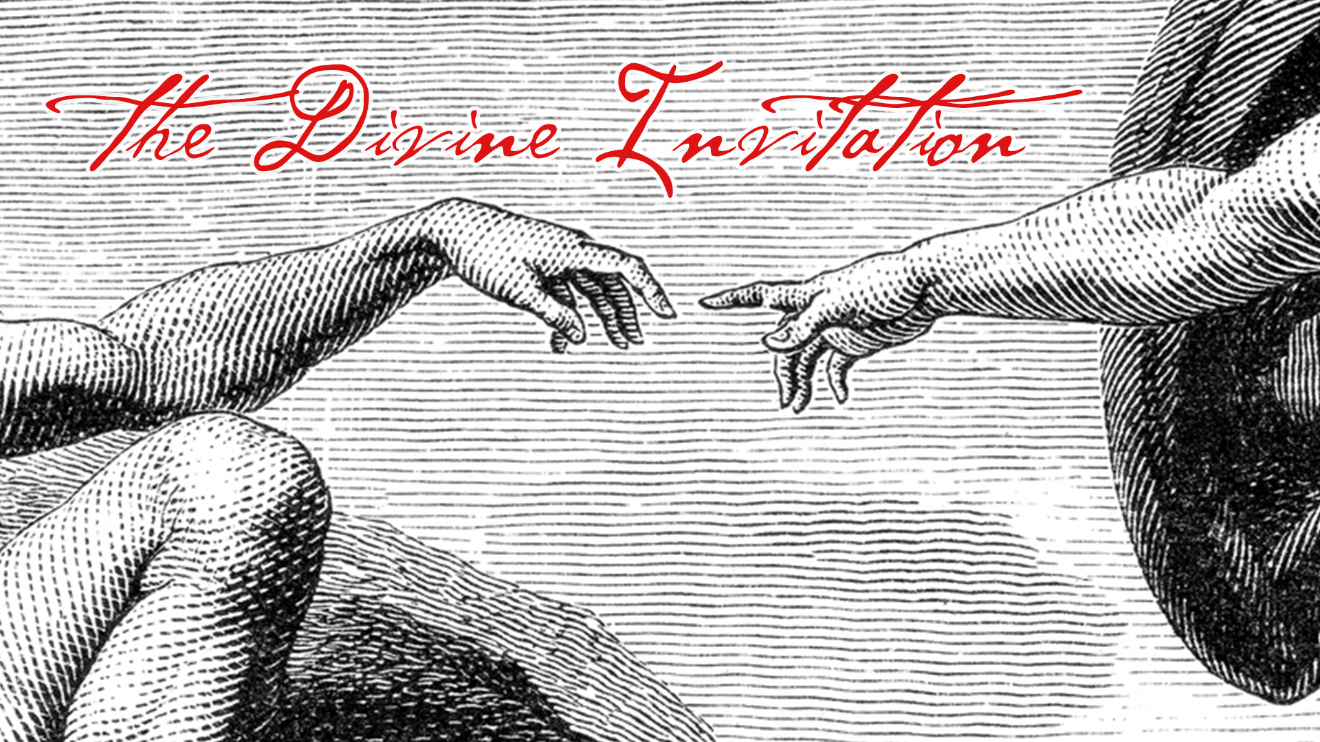
LC Study Guide
The Divine Invitation
The Passage: Matthew 16:13-19
October 16-28

Introduction

Welcome back – let’s jump right in. With this year’s theme “For the Good of the World,” we’re reminding ourselves that our faith isn’t just good for each of us individually; we also want to seek the good of our friends, family, and neighbors. So during our gatherings this year, we want to take time to help move each other along in this mission and identify and celebrate what God is doing. Today we want to ask:
As we “go,” how has your walk with God been a blessing to someone else this week? Or where might He be inviting you to bless someone this week?

Let’s keep our hearts alert to how we are living out Jesus’ message of loving and serving others.

Matthew 16:13-19

¹³ When Jesus came to the region of Caesarea Philippi, he asked his disciples, “Who do people say the Son of Man is?”
¹⁴ They replied, “Some say John the Baptist; others say Elijah; and still others, Jeremiah or one of the prophets.”
¹⁵ “But what about you?” he asked. “Who do you say I am?”
¹⁶ Simon Peter answered, “You are the Messiah, the Son of the living God.”
¹⁷ Jesus replied, “Blessed are you, Simon son of Jonah, for this was not revealed to you by flesh and blood, but by my Father in heaven. ¹⁸ And I tell you that you are Peter, and on this rock I will build my church, and the gates of Hades will not overcome it. ¹⁹ I will give you the keys of the kingdom of heaven; whatever you bind on earth will be bound in heaven, and whatever you loose on earth will be loosed in heaven.”
Unseen in this text, but for the sake of context, Jesus’ rivalry with the Pharisees and Sadducees is escalating. The Pharisees were the larger religious establishment of the day. They were generally moral and traditional. The Sadducees were also religious, but were fewer number, wealthier, and belonged to a more elite class. It’s been said their grasp on the Torah was not as strong as the Pharisees. Both groups were rivals to each other to some degree but both saw how big of a threat Jesus was to all of them.
Back, in chapter 15, Jesus fed the 5,000 and in the beginning of this 16th chapter, the religious establishment is trying to entrap him. Which leads to Jesus leaving the Sea of Galilee region and traveling to Caesarea Philippi, which is a remote Roman-colonized city on the northernmost edge of Israel. It was a very pagan city, meaning, there was very virtually no presence of the religious establishment. Picture this as Jesus taking his disciples away on a retreat to get centered on identity and mission.

O – What do you see in the text that peaks your curiosity?

O – Of all the names the disciples could have mentioned (Moses, Abraham, David, etc.), which do they cite? What did these names have in common?
(They were cherished prophets of Israel. Though the word on the street was inaccurate, this was an honor. It also reveals the people have no category for Jesus but they revere him.)

I – Why does Jesus even ask them what people are saying about him? Being omniscient, doesn’t Jesus already know? Also, Jesus doesn’t seem like an individual who is going to alter his plan based on public perception, so what is the purpose of this question?
(As interesting as it is to speculate on what Jesus knew and what Jesus chose to keep hidden from himself, one way to see this passage is to appreciate that this question is really for the disciples to consider. But even more, Jesus’ question is giving his disciples agency. They fell in line with Jesus as their rabbi, but now, an even larger possibility has to be considered – Jesus is the Christ? Is Jesus God’s chosen deliverer for Israel and for the world?)

I – We cannot miss the importance of Peter’s confession that Jesus is the Messiah. This is the clearest profession of such a pronouncement and to his credit Peter confesses the amazing truth. In turn, Jesus says in verse 18 that upon this “rock [he] will build [his] church.” Much discussion has been generated on Jesus’ words here. Did he mean on Peter specifically? Did he mean on the foundation of the faith of his followers (Peter’s confession)? Can the answer be both? What do you think Jesus means and what is the significance of his statement?
(We’re talking about Jesus, so yes, the answer can be two-fold. A theme of Jesus’ ministry is to empower his faithful followers. So Peter being blessed as a pillar of the early church is a statement that Jesus is going to use ordinary people, empowered by the Spirit, to do extraordinary things. But it’s two-fold in the sense that Peter only receives this blessing because he was the one who makes the confession that Jesus is the Messiah. Thus, the church being built then and now is upon those who profess Jesus is Lord.)

A – The New Testament and church history tell us of the incredible work of Peter and the other Apostles. And we must also appreciate that Jesus is still building his church today, with and through us. How does life change for us believing that the gates of Hades will not prevail against the people of God?

A – Jesus tells his followers in verse 19 that they’ve been given the keys to bind
and loose for eternity. Who and what should we prioritize to be sought for the kingdom? What is it that we ought to forfeit? Or in other words, what should we pursue and what should we avoid?

- Please note that not all these questions are to be asked in a single meeting. Take some time to prayerfully discern what will serve your LC the best. Select and reword the questions that best fit your voice and your Life Community group.
- Complement these questions with “process questions” (what else? what more? what do others think?)
- When you ask questions, give people ample time to think and respond. Wait. Take your time; don’t rush people but encourage participation. Avoid answering your own questions!
- Application: Pace the study to conclude with difference-making application.
- Secondary texts—use other texts sparingly, even if they are relevant. Such texts will push you into “teaching” rather than facilitating, causing people to feel distracted or de-powered.

