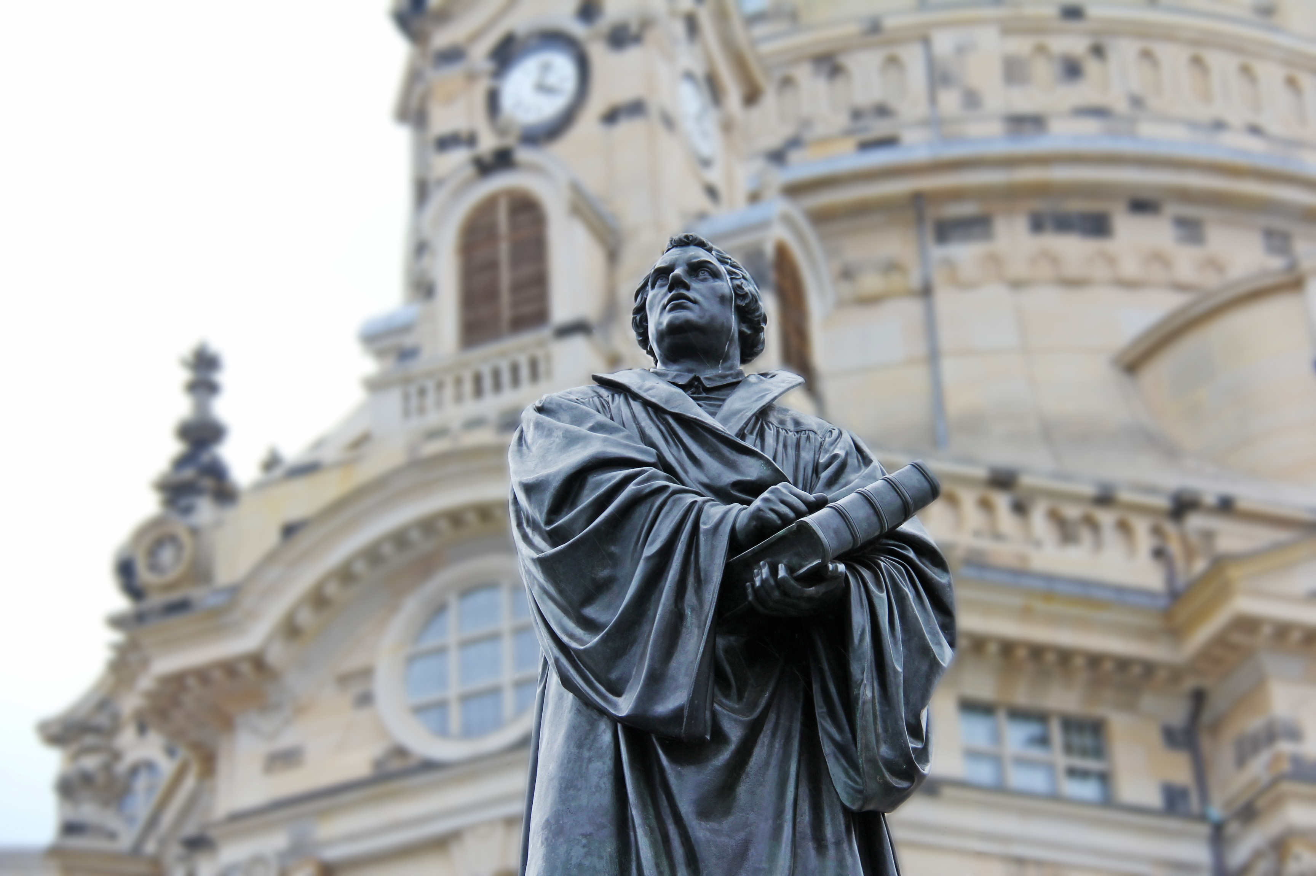
LC Study Guide
The Divine Invitation
The Passage: 1 Peter 2:9-10
October 30 – November 12

Introduction
We’ve paused our Divine Invitation series to reflect on the 500th Anniversary of the Protestant Reformation. What might the Church and society look like today had Martin Luther not nailed the 95 Theses on the Wittenberg door on October 31, 1517 and had the invention of the printing press not coincided in that time period?

While we want to avoid debating all the positives, negatives and in-betweens of the Reformation, we do want to focus on a particular theme of it – the intended empowerment of the Church.

This teaching was a gift to the Jesus followers and to the world, and today we ought to ask ourselves how we can continue to grow in our understanding of the empowerment of the Church. What might the next 500 years look like as a result of living this out?

1 Peter 2:9-10
⁹ But you are a chosen people, a royal priesthood, a holy nation, God’s special possession, that you may declare the praises of him who called you out of darkness into his wonderful light. ¹⁰ Once you were not a people, but now you are the people of God; once you had not received mercy, but now you have received mercy.

O – It is necessary to see the Reformation as a revolutionary and startling moment in Church history and in Western history (as well as its impact on the Middle Eastern, Eastern, and the Global South of course). What do you see as potentially revolutionary here in these two verses that Luther greatly emphasized?

O – It’s also helpful to remember that in 1517, the vast majority of Christians did not have access to a Bible. One reason was literacy. Another was translation. Westerners did not have the Bible translated into their own language. It was mostly available in Latin, Greek, Coptic, Arabic, and Chinese among a few others. It was not translated into English until 1527.

A third reason was accessibility – there was no printing press, meaning a copy of the Bible was rare and kept under lock at certain churches, cathedrals and seminaries. Thus, Biblical teaching had to come directly from the priest.

Given all this context, how might the Church be changed if more people had access to the Bible in their own language? What else would be different? Why would a passage like this be significant?

I – Why do you think Peter is emphasizing these words, “chosen,” “royal,” and “holy”?
How does this framing help us understand what God calls the Church to be—then, today, and in the future?
(Peter is using these words to equate Christ-followers, Jewish or Gentile, to the Old Testament understanding of Israel. Israel was called to worship the true God and proclaim His hope to all the nations. Jesus calls His Church to do this too.)

A – How might the global Church and local expressions of the church be different if we grew in seeing ourselves as priests in God’s Kingdom?

A – Let’s spend some time in what we might call “holy imagination.” What might the next 500 years look like if we lean into the theological concept of the “Priesthood of all believers”?
What could this next season in 2017-18 look like as we begin the next millennium since the Reformation?

- Please note that not all these questions are to be asked in a single meeting. Take some time to prayerfully discern what will serve your LC the best. Select and reword the questions that best fit your voice and your Life Community group.
- Complement these questions with “process questions” (what else? what more? what do others think?)
- When you ask questions, give people ample time to think and respond. Wait. Take your time; don’t rush people but encourage participation. Avoid answering your own questions!
- Application: Pace the study to conclude with difference-making application.
- Secondary texts—use other texts sparingly, even if they are relevant. Such texts will push you into “teaching” rather than facilitating, causing people to feel distracted or de-powered.

