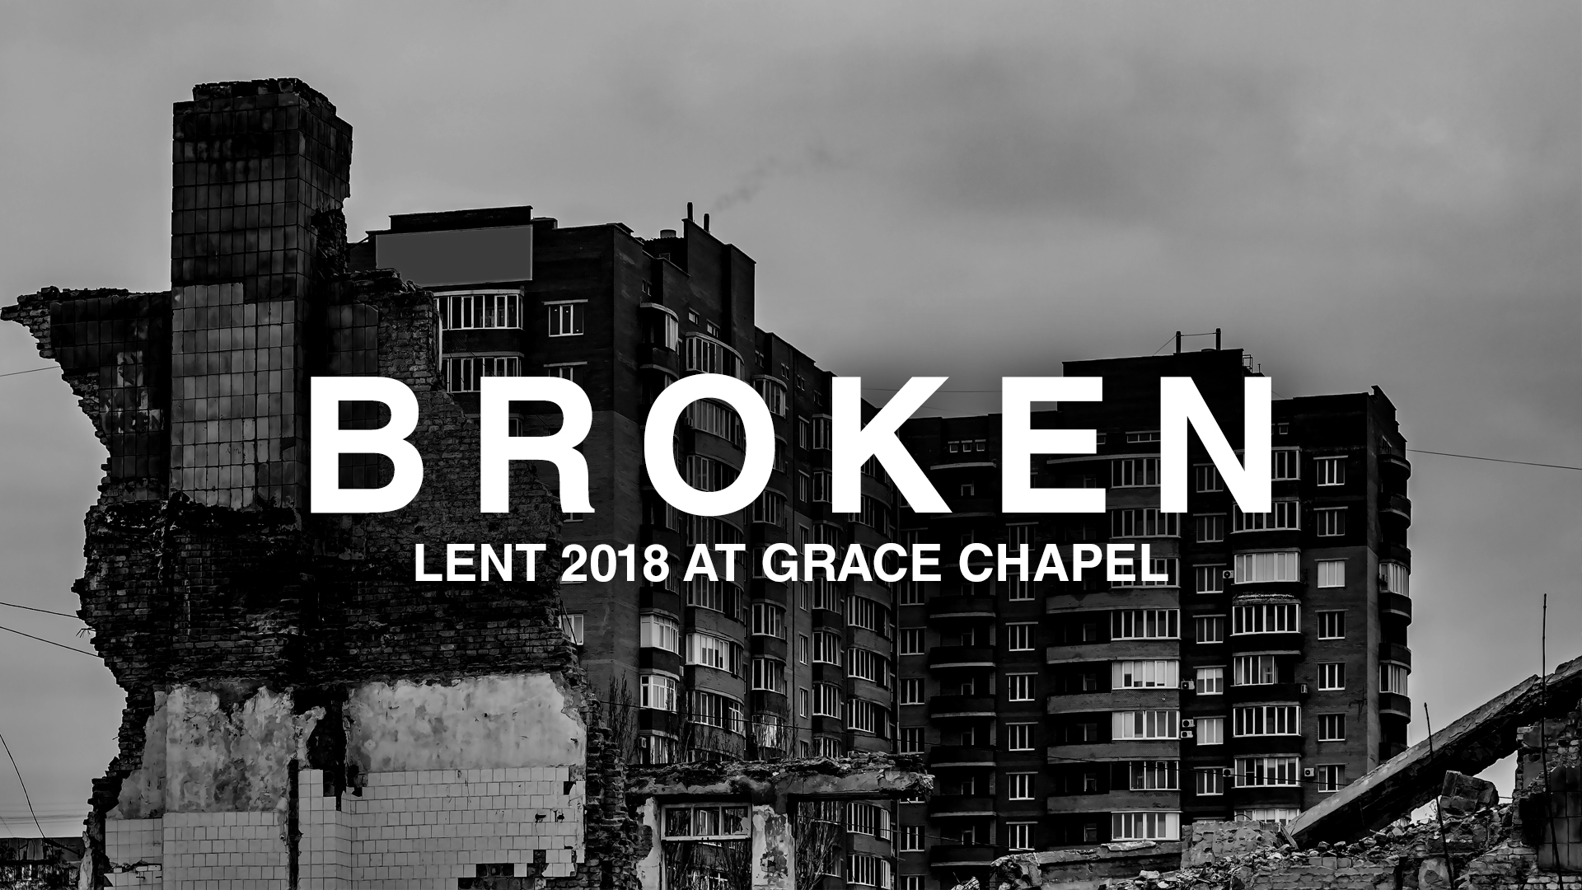
LC Study Guide
“Broken”
The Passage: Micah 6:6-13
February 19 – March 4

How to use the LC Study Guide

Hello Leaders! Thank you for your ongoing commitment to pursue Christian community and the study of Scripture that leads to life transformation in Christ and strives to serve “the other.”

These studies have been designed with the following aspects in mind:
- To facilitate a discussion on the passage of Scripture that was preached that particular Sunday using the Inductive Bible Study Method (not necessarily on the themes of that particular sermon). In summary, this method stresses “Observation” (what the reader can see from the text), “Interpretation” (what we can learn when we study the text with various tools, commentaries, and resources), and “Application” (how we can apply the Scripture to our lives).
- Groups using this study range from the new leader to the highly experienced. Groups themselves have their own context. This study attempts to hit the middle. The stronger studies require about an hour or two of leader preparation to contextualize this resource to the needs and personalities of your group.
- In addition to prep time, please spend time in prayer during preparation and before and after the study. It’s the power of the Holy Spirit that illuminates the Word of Scripture and we are humbled that He uses our combined efforts as part of this work. (For more tips on using this study, please see the endnotes.)

As always, we are so grateful for you, your gifting, your servant leadership and all that you do for the cause of Christ. Please let us know if we can help you in any way.

Grace and peace,
Pastor Tim, on behalf of the LC Team

Introduction

“Broken” is the new sermon series for Lent where we look at seven of the twelve minor prophets of the Old Testament. The prophets were sent by God to call out the sin and injustice of Israel, warning them of God’s judgment and inviting them to repentance until the Messiah appears on the scene. Today, we want to see both the brokenness within and the Lord’s invitation to all.

Context

Micah’s ministry spans across the reigns of 3 kings and covers about 50 years from 775-725 BC. He overlaps some of Hosea’s and Amos’s respective ministries and is a contemporary of Isaiah.
Israel and Judah have long been divided into 2 kingdoms and at this point in the book, Assyria is about to conquer Samaria, which becomes the capitol of the Northern Kingdom. Micah is writing from Judah, the Southern Kingdom, and is prophesying their demise. Micah is the first to say that Jerusalem will be destroyed and about 150 years later, in 587 BC, it is. Micah has spent most of the book calling out the corruption of Israel’s leaders. Here in Micah 6, he invites all of Israel to live a life of repentance and justice before the Lord.

Micah 6:6-13

⁶ With what shall I come before the Lord
and bow down before the exalted God?
Shall I come before him with burnt offerings,
with calves a year old?
⁷ Will the Lord be pleased with thousands of rams,
with ten thousand rivers of olive oil?
Shall I offer my firstborn for my transgression,
the fruit of my body for the sin of my soul?
⁸ He has shown you, O mortal, what is good.
And what does the Lord require of you?
To act justly and to love mercy
and to walk humbly with your God.
⁹ Listen! The Lord is calling to the city—
and to fear your name is wisdom—
“Heed the rod and the One who appointed it.
¹⁰ Am I still to forget your ill-gotten treasures, you wicked house,
and the short ephah, which is accursed?
¹¹ Shall I acquit someone with dishonest scales,
with a bag of false weights?
¹² Your rich people are violent;
your inhabitants are liars
and their tongues speak deceitfully.
¹³ Therefore, I have begun to destroy you,
to ruin you because of your sins.

O – Reread the passage a few times for yourself. What do you find confusing? What resonates with you?

O – Micah writes the invitation to repentance first and then does something interesting. What do you see happening in verses 9-13? Why do you think Micah writes it here instead of in the beginning of this section?
(Part of it was to repeat the judgment of rejecting God’s invitation. It’s also a style of writing where the author builds to the central point and then builds out.)

O – There has always been a temptation to give to God everything but one’s heart. What is Micah suggesting that the people of Israel are doing in verses 6-7?

I – The message God is giving through Micah is, “Save your fancy offerings. Do not include ancient sacrifices” (which sadly were part of pagan worship).… and do what instead? Why is God more interested in this?

O – Identify some of the modern-day equivalents of verses 9-13 and the judgment for practicing them. Note: The “ephah” was an ancient measurement of a bushel. The deceitful would short-change how much grain or wheat they would include for the agreed upon price. In the Jewish understanding of honoring God and one another, they were not cheating their fellow citizen, but also cheating God.

A – How does living out Micah 6:8 show our repentance and change our lives?

- Please note that not all these questions are to be asked in a single meeting. Take some time to prayerfully discern what will serve your LC the best. Select and reword the questions that best fit your voice and your Life Community group.
- Complement these questions with “process questions” (what else? what more? what do others think?)
- When you ask questions, give people ample time to think and respond. Wait. Take your time; don’t rush people but encourage participation. Avoid answering your own questions!
- Application: Pace the study to conclude with difference-making application.
- Secondary texts—use other texts sparingly, even if they are relevant. Such texts will push you into “teaching” rather than facilitating, causing people to feel distracted or de-powered.

