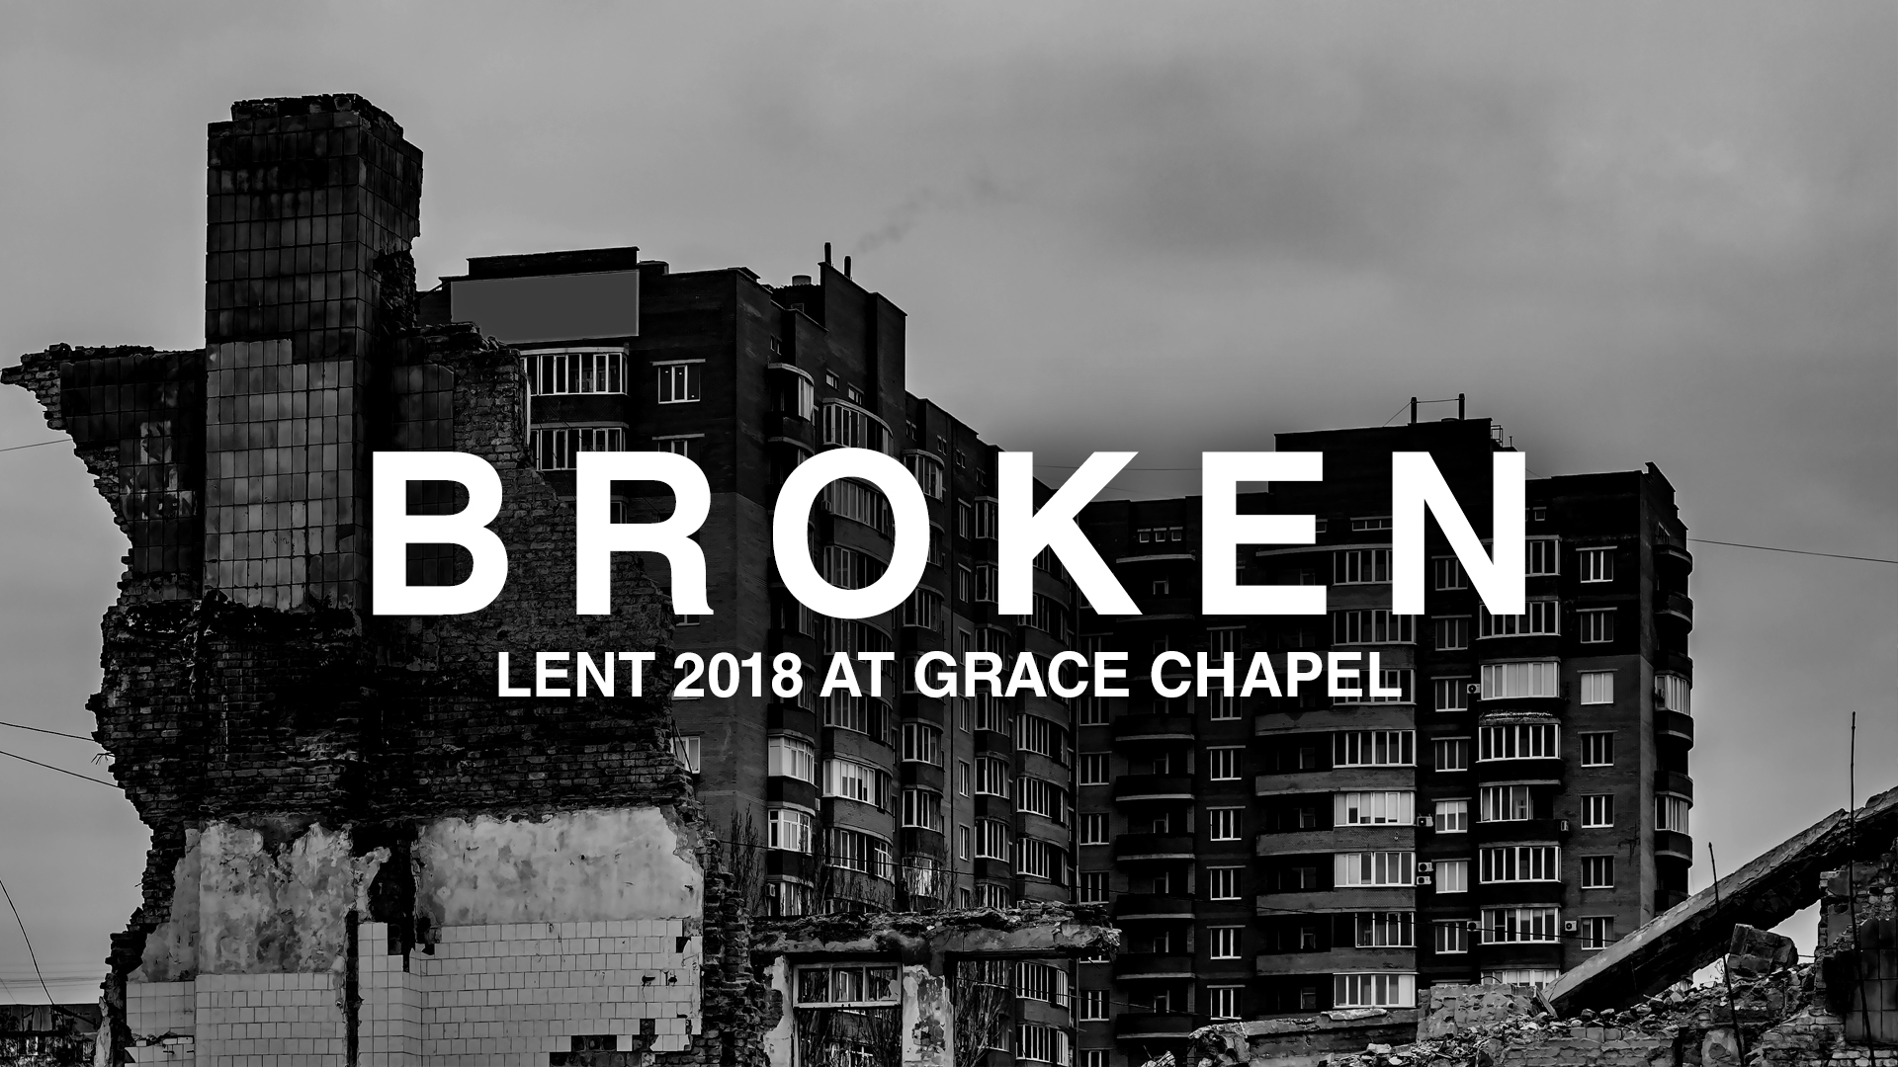
LC Study Guide
“Broken”
The Passage: Habakkuk 2:10-20
March 5 – March 19

How to use the LC Study Guide

Hello Leaders! Thank you for your ongoing commitment to pursue Christian community and the study of Scripture that leads to life transformation in Christ and strives to serve “the other.”

These studies have been designed with the following aspects in mind:
- To facilitate a discussion on the passage of Scripture that was preached that particular Sunday using the Inductive Bible Study Method (not necessarily on the themes of that particular sermon). In summary, this method stresses “Observation” (what the reader can see from the text), “Interpretation” (what we can learn when we study the text with various tools, commentaries, and resources), and “Application” (how we can apply the Scripture to our lives).
- Groups using this study range from the new leader to the highly experienced. Groups themselves have their own context. This study attempts to hit the middle. The stronger studies require about an hour or two of leader preparation to contextualize this resource to the needs and personalities of your group.
- In addition to prep time, please spend time in prayer during preparation and before and after the study. It’s the power of the Holy Spirit that illuminates the Word of Scripture and we are humbled that He uses our combined efforts as part of this work. (For more tips on using this study, please see the endnotes.)

As always, we are so grateful for you, your gifting, your servant leadership and all that you do for the cause of Christ. Please let us know if we can help you in any way.

Grace and peace,
Pastor Tim, on behalf of the LC Team

Introduction

We continue in our Lenten “Broken” series as we look at seven of the twelve minor prophets of the Old Testament. The prophets were sent by God to call out the sin and injustice of Israel, warning them of God’s judgment and inviting them to repentance until the Messiah appears on the scene. Today, we want to tackle the issue of violence in the book of Habakkuk.

Context

The reality is the text does not give us much information about the life of Habakkuk and it’s possible that his name comes from an herb. You read that right.

Habakkuk’s ministry takes place during the decline and fall of the Southern Kingdom of Judah (626-586 BC). Judging from the timeline and his knowledge of the Babylonians, he is likely a contemporary of the prophet Jeremiah, maybe of Nahum also and perhaps prophesying when Assyria (who had conquered the Northern Kingdom) was losing its power.

Conditions during the prophet’s life would have gone from excellent materially under the final bit of prosperity under Josiah to desperation as Jerusalem became encircled and finally destroyed in 586 BC. Habakkuk’s unique ministry is a lament of suffering, advocating for his nation, and a calling on God to punish the wicked and violent Babylonians.

Here in Chapter 2, the words given are from God. Though Babylon was used to as an instrument of judgment, God is calling out the Babylonians for their wicked ways. (Their reign as a Middle-Eastern power is short-lived and eventually the Persian ruler Cyrus overtakes them in 539 BC.)

Habakkuk 2:10-20
¹⁰ You have plotted the ruin of many peoples,
shaming your own house and forfeiting your life.
¹¹ The stones of the wall will cry out,
and the beams of the woodwork will echo it.
¹² “Woe to him who builds a city with bloodshed
and establishes a town by injustice!
¹³ Has not the Lord Almighty determined
that the people’s labor is only fuel for the fire,
that the nations exhaust themselves for nothing?
¹⁴ For the earth will be filled with the knowledge of the glory of the Lord
as the waters cover the sea.
¹⁵ “Woe to him who gives drink to his neighbors,
pouring it from the wineskin till they are drunk,
so that he can gaze on their naked bodies!
¹⁶ You will be filled with shame instead of glory.
Now it is your turn! Drink and let your nakedness be exposed!
The cup from the Lord’s right hand is coming around to you,
and disgrace will cover your glory.
¹⁷ The violence you have done to Lebanon will overwhelm you,
and your destruction of animals will terrify you.
For you have shed human blood;
you have destroyed lands and cities and everyone in them.
¹⁸ “Of what value is an idol carved by a craftsman?
Or an image that teaches lies?
For the one who makes it trusts in his own creation;
he makes idols that cannot speak.
¹⁹ Woe to him who says to wood, ‘Come to life!’
Or to lifeless stone, ‘Wake up!’
Can it give guidance?
It is covered with gold and silver;
there is no breath in it.”
²⁰ The Lord is in his holy temple;
let all the earth be silent before him.

O – Most of the passages we look at in our studies focus on the sins of Israel. However, this passage was selected because of the uniqueness found in Habakkuk. Here in Chapter 2, God is responding to the wickedness and violence of Israel’s oppressor, the nation of Babylon. Reread the passage a few times for yourself. What do you hear in God’s words here in Chapter 2?

O – Identify the various forms of sin the Babylonians committed towards Israel, unto each other, and unto God.
(This section includes violence against Lebanon, debauchery, and the worship of false idols).

I – The chapter ends with a bit of a mic-drop. What do you think is happening here?
(God is giving a very clear warning to the mighty Babylonians. The way of violence and
wickedness will not go unanswered. Just like God judged the idolatry of Israel, God will also judge the evil of Babylon. The chapter concludes with the reminder that only God is sovereign and only God is holy.)

*Leader note: Depending on your group’s collective knowledge of Scripture, you may want to consider how to combine the next two questions. One option is to use the answer of the Interpretative question as the context to ask the Application question.

I – Returning to the middle of the chapter in verse 17, why do you think Habakkuk uses “Lebanon” to represent all of Israel?
(Lebanon is often remembered for its tress and forests as in the “cedars of Lebanon” in Psalm 104:16. It was one of the first places Joshua settled when the Israelites entered the “promised land.” Lebanon represented a historical and spiritual mark of promise and worship for Israel.)

A – Now that we can appreciate that Lebanon represents the answer God promised Moses when the Israelites were in Egypt, what are the “Lebanons,” the promised moments in our lives?
How have we given God our gratitude and centered our worship on Him?
How have we made similar mistakes as Israel did throughout its history?
And what ought we do moving forward?

- Please note that not all these questions are to be asked in a single meeting. Take some time to prayerfully discern what will serve your LC the best. Select and reword the questions that best fit your voice and your Life Community group.
- Complement these questions with “process questions” (what else? what more? what do others think?)
- When you ask questions, give people ample time to think and respond. Wait. Take your time; don’t rush people but encourage participation. Avoid answering your own questions!
- Application: Pace the study to conclude with difference-making application.
- Secondary texts—use other texts sparingly, even if they are relevant. Such texts will push you into “teaching” rather than facilitating, causing people to feel distracted or de-powered.

